Business Case
Project Name | Telephone Advice and Guidance | Commencement Month | November 2019
Project Manager |  | Programme Lead (Associate Director)
Executive Lead |  | Clinical Lead
Is the scheme transactional or transformational? | Transformational | Clinical Director

Which of the CCG strategic objective(s) does the scheme link to?
Achieving a sustainable system
Development of collaborative working
Developing integrated care at local level
Primary care development
Safe, effective care providing the best possible health outcomes and patient experience
Commissioning a safe and sustainable Children’s service

Objectives
[Area] is committed to working as a system to deliver sustainable, high quality care for its citizens. Historically, demand for outpatient services across the ICP has been increasing but capacity is not. From 2017/18 to 2018/19 referrals to secondary care increased by 6.5%.

Mismatched capacity to demand affects patient experience, clinical quality and system sustainability. Recognising this challenge, the ICP must consider how to reduce referrals to secondary care. There is a programme of work around Outpatient Transformation exploring four ways to do this:
- Supporting patients with long term conditions to self-manage and make informed decisions about their onward treatment options
- Enhancing management in primary care by giving GPs access to relevant education, advice and tools that will enable them to manage more patients in primary care
- Improving the systems and processes used to manage demand
- Implement New Models of Care (i.e. alternatives to the traditional model of face to face contact) in secondary care

The impact of these initiatives is already paying dividends, with demand in 2019/20 (year to date) showing a 7.1% reduction compared to the previous year. However the system is confident that this progress can be built upon and the reduction further improved. This Business Case relates to the second – “enhancing management in primary care by giving GPs access to relevant education, advice and tools that will enable them to manage more patients in primary care”. The objective is to maximize the impact of Advice and Guidance (A&G), an existing local tool has had some impact but could be enhanced. Getting this right will:
- Improve access and patient experience – facilitating a prompt response / outcome
- Deliver system efficiency – avoiding referrals to secondary care, supporting delivery of the Referral Management and Virtual Hospital System Efficiency scheme.

Whilst the focus of this business case is on planned care, it is also noted that the increase in demand is mirrored in urgent care, where there was a 1% increase from 2018/19 to 2019/20 (YTD at month 4) – on average, 3 additional attendances to A&E per day. A demand management solution that also address this challenge would be optimal.

Rationale & Evidence
There is recognition that, with advice and guidance from a specialist, referrals can be avoided and patients can be managed within primary care. When an A&G system is in place it can:
- enable GPs to better manage conditions in primary care
- reduce the number of unnecessary outpatient referrals
- increase capacity for acute consultants to see only the most appropriate GP referred patients in secondary care.

An A&G service was set up in [AREA] in April 2016. Starting in Cardiology at the [Trust], there are now 21 specialties offering A&G. The service has been well received:
- 5580 A&G requests have been processed since it was launched
- Response times are good
  - Average response time is 2 days
  - Only 9.1% took longer than 5 working days
- As at June 2019, only 73% of A&G prevented an outpatient attendance

Initially A&G volumes were increasing month on month but usage of A&G has stabilized. The peak requests came in Oct-18 (260) and this has since averaged at 220 per month, with a low of 153 (May-19).

Limited use of existing advice and guidance services via e-RS is multi-factorial:
- it is time consuming and not always easy to use
- it can be difficult to engage in a dialogue, which is challenging when discussing complex cases
- the outcomes from written advice and guidance are not always positive enough to justify the effort required
- job plans haven’t been updated consistently, meaning that not all Consultants are allocated to provide A&G and capacity to respond doesn’t necessarily match demand

To date in [AREA], A&G services have only been used for planned care. This is because the timeframe for responses has been too long to be useful in the urgent care setting.

Options
This Business Case considers how to support GPs to manage more patients in primary care in primary care by facilitating access to relevant education, advice and tools. The premise is that whilst A&G has already had some positive impact locally, it could be enhanced. The options to enhance the A&G impact are:

Title | Description | Benefits | Risks
1. Do nothing | Continue to provide A&G using eRS and the existing systems and processes. | Maintaining the status quo will ensure minimal disruption and performance is currently adequate. | Usage has been stablising and is at risk of decline without focused improvement.
2. Improve existing A&G systems and processes | Continue to provide A&G using eRS and review the existing systems and processes to identify opportunities to improve e.g. review of Consultant Job Plans | Making improvements to the existing process will make best use of resources | Process improvements will be limited in impact and will require time / support where there is limited additional capacity
3. Use Consultant Connect with local Consultants only | Use Consultant Connect as a platform to enable access to a telephone A&G service which allows GPs to speak with local hospital specialty consultants. | GPs have the option to make a call directly to a Consultant for instant advice | There may not be enough Consultants locally to respond in a timely manner, resulting in missed connections
4. Use Consultant Connect with access to national network | Use Consultant Connect as a platform to enable access to a telephone A&G service which allows GPs to speak with specialty consultants from across a national network. | GPs have the option to make a call directly to a Consultant for instant advice | There may be insufficient usage of the national network to make the additional investment value for money.

Preferred option:
Combination of Option 2 (improve current systems and processes) and Option 4 (use Consultant Connect with access to national network). As previously stated, the limited impact of the existing A&G services via e-RS is multi-factorial and it is felt that combining options 2 and 4 will address all of the contributing factors, thus optimising the potential impact of A&G.

Risks (Include Risk log/scoring as Appendix)
IF | THEN | MITIGATION
Consultants are already engaged in the activities identified in the existing outpatient transformation programme | There will be limited capacity to participate in an additional piece of work requiring understanding of a new system and related new ways of working | - Prioritise activities based on anticipated impact  - Impactful messaging to promote the solution and to demonstrate alignment of objectives
GPs opt to continue to use the existing eRS A&G platform | The additional investment in the Consultant Connect platform will not be returned | - Promote benefits of dual options to GPs  - Communication and engagement plan targeting primary and secondary care  - Identified GP advocates  - Set-up support provided by Consultant Connect
Local Consultants do not answer the call and the response is given by a Consultant from the national network | They will not have any local knowledge, resulting in incomplete responses | - Calls are recorded and if quality concerns arise the content can be audited  - For planned care, the majority of call outcomes will be to refer or not refer – following this conclusion, the GP will adhere to existing local processes.  - For urgent care, where the pathway set up may be more complex (in order to reflect local nuances) Consultant Connect spend a 12-16 set up period to ensure that pathways are reflective of local systems and processes

Recommendations
Currently, A&G is delivered electronically via the e-Referral system and there is opportunity to address known shortfalls and enhance the capability by taking forward two of the explored options:

- Option 2: Improving current systems and processes
Whilst A&G works well currently, analysis shows us that some GPs and practices use the service more than others and that some Specialties are utilised more. We know that there are limitations in the current set-up that reinforce these variations and that improvements could minimise variation, resulting in improved uptake of A&G via eRS. The most obvious improvements would be to review and update Consultant Job Plans to ensure that A&G capacity meets demand (leading to improved response times).

- Option 4: Using Consultant Connect and the national network
Use of Consultant Connect has the potential to expedite access to specialist advice and when used nationally has been shown to increase the impact of A&G.

Proceeding with option 2 alone will have some but limited impact because even with significant process improvement, the eRS platform will always have some time delay. By coupling the process improvement with access to telephone A&G via Consultant Connect (where on average calls are connected within 39 seconds) there will always be access to an immediate response – leading to greater improvement in the impact of A&G on reducing referral demand in secondary care.

Combined these two options will optimally meet the objective of giving GPs access to relevant education, advice and tools that will enable them to manage more patients in primary care.

The table below gives an indication of the impact that Consultant Connect has had in other areas:

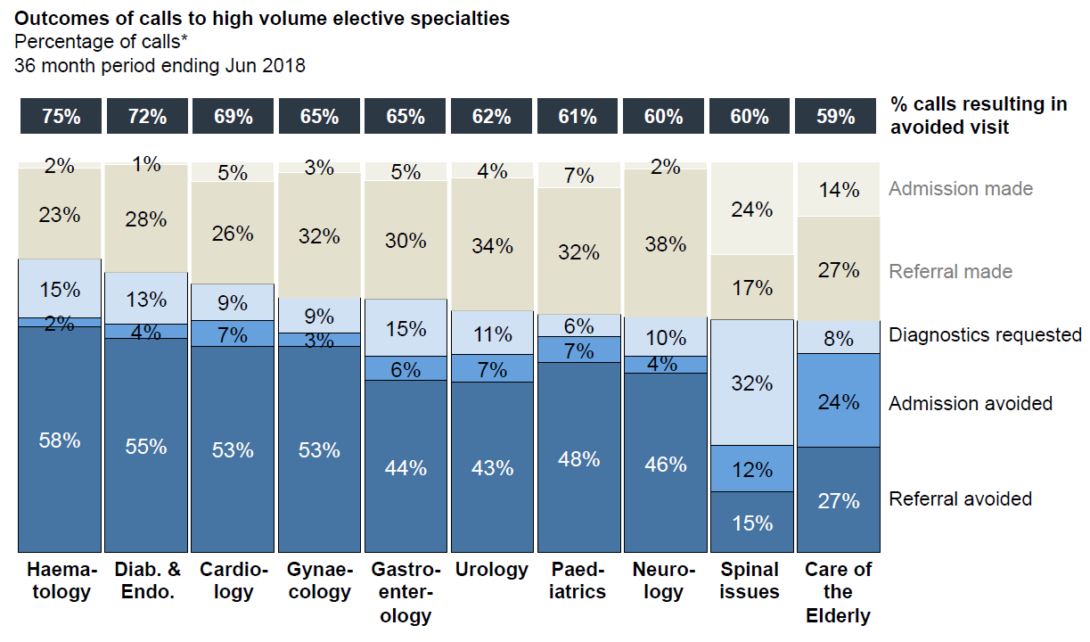
The Consultant Connect platform has been used in South East London in addition to the eRS platform. The data overleaf shows how implementation of Consultant Connect has led to an overall increase in A&G usage– the volume of A&G nearly doubled over a 1-year period. The experience in South East London and other systems using Consultant Connect alongside eRS is that the A&G conversation rate is higher with Consultant Connect than with eRS. For instance, in South East London it was 66% locally, versus 70% when using the Consultant Connect national platform. The reason cited for this was that the national network is largely manned by Consultants with experience providing A&G, who have honed the required skillset.
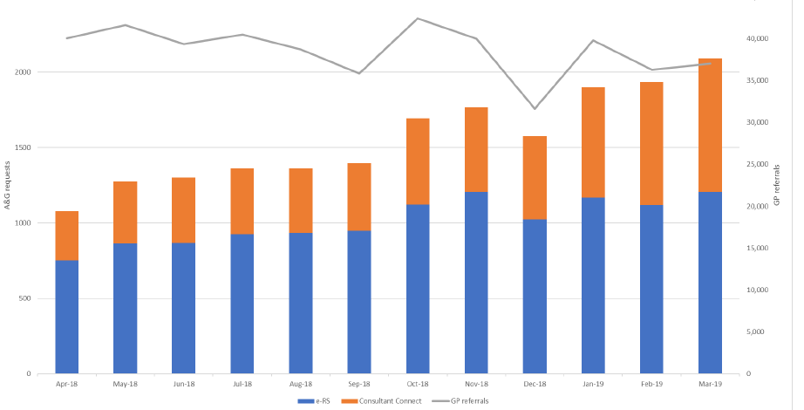
GP feedback in South East London was positive:
- 69% of GPs would recommend Consultant Connect
- 79% received helpful advice
- 81% felt Consultant Connect had enhanced their knowledge

Consultant Connect is already being used in [Neighbouring] CCG. [Neighbouring Trust] have directly commissioned the service and it is in use for Ambulatory Emergency Care Unit and Surgical Assessment Unit (Urgent Care) and Gynaecology, Neurology, Paediatrics, SAMS – Geriatric Advice and Guidance (Elective care). The [Trust] data is summarized below, and reflects the national picture with between 60-70% referral or admission avoidance.

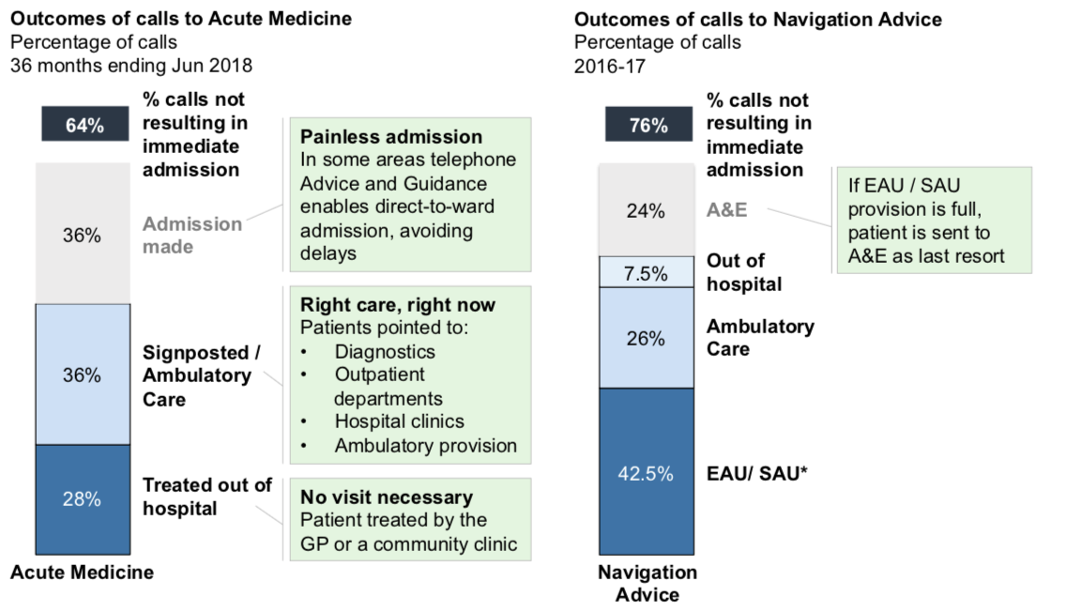
[TRUST] and local GPs like the system and have been considering additional expansion opportunities:
- Elective Care – Expand the current service to include all Specialties and Hotlines across the hospital. This can be alongside eRS/email or instead of eRS/email. Where the service cannot be resourced locally consider using the National Consultant Network
- Urgent Care – Expand the service across all of Urgent Care and make it mandatory for GPs to use the service if they are thinking of sending a patient to A&E. Include the UTC as either/both caller and/or advice provider. Include GP Liaison Nurse
- Ambulance/Paramedics – Get SECAmb using the service
- Care Homes – Consider allowing nurses/carers at Care Homes access to certain A&G to certain specialties
- Internal Hospital Communication – Expand the Hospital Service to allow cross hospital communication, reducing C-C referrals and discharge management
- Mental Health – expand the project to include the local Mental Health Trust. Provide Physical A&G to the Mental Health Trust and Mental Health A&G for [TRUST] clinicians and GPs

[Different Area] CCG is scoping outpatient transformation work and have identified the opportunity to utilise Consultant Connect to compliment this work programme. The outpatient transformation plans are still emergent and the system is not ready to make a decision on whether to use Consultant Connect at this time.

Key Activities & Milestones
The system and process improvements will be taken forward as part of the existing outpatient transformation programme, through the New Models of Care workstream. The tasks to be undertaken include (this may expand as more is understood about the current problems):

No. | Milestone Description | Owner | Planned date of completion | Tolerance
 | JOB PLANS
1 | Review existing A&G activity – volumes and response times | CCG | Aug 19 | Complete
2 | Compare activity to job planned availability at a specialty level | [lead] | Oct 19 | 1 month
3 | Match job planned capacity to demand | [lead] | Dec 19 | 2 months
 | COMMUNICATION
4 | Investigate causes of delayed responses (over 5 days) and address issues where possible | CCG | Oct-19 | 1 month
5 | Review quality of A&G requests – audit from a selection of specialties – and make recommendations for improvement | [lead] | Nov-19 | 1 month
6 | Review quality of A&G responses – audit from a selection of specialties – and make recommendations for improvement | CCG | Nov-19 | 1 month
7 | Use learning from audits to develop best practice guidelines and share as part of A&G comms | CCG | Dec-19 | 1 month

The A&G telephone platform via Consultant Connect would be able to launch 4 weeks after funding approval. Consultant Connect provide implementation support as part of the fee.

Since Consultant Connect adds value in both Elective and Urgent care the proposal would be to launch in phases. (Phase 2, into unplanned services, will take longer in order to account for local pathway variations and amendments that may need to be made to the system to accommodate these).

Major application = elective but roll out benefits into non-elective

Phase 1 – 4 week implementation | Phase 2 – 16 week implementation
Cardiology | Acute Medicine
Dermatology | Ambulatory Care
Diabetes and Endocrinology | ED
Gastroenterology
Gynaecology
Haematology
Neurology
Paediatrics
Renal Medicine
Respiratory Medicine
Rheumatology
Urology

No. | Milestone Description | Owner | Planned date of completion | Tolerance
8 | Business Case for Consultant Connect | CCG | Oct 19 | 1 month
9 | Financial approvals, contracting | CCG | Nov-19 | 1 month
10 | Service set up, including provider engagement, system set up, IG agreements, comms etc | CC | Dec-19 | 1 month
11 | Launch Consultant Connect Phase 1 | CCG | Dec-19 | 1 month
12 | Scoping Urgent Care requirements and implementing solutions | CC | Feb-20 | 1 month
13 | Launch Consultant Connect Phase 2 | CCG | Mar-20 | 1 month
14 | Review impact | CCG | Sept-20 | 1 month

Time & Resource
The delivery of localised system and process improvements would be done within the existing resource, managed through the outpatient transformation programme.

The delivery of the Consultant Connect telephone A&G and access to the national platform would be at a cost of £5000 per month. The A&G tariff of £25 would be charged per call connected – this is aligned to the existing A&G tariff.

Potential Saving Per Annum in urgent care | £72,046
Potential Saving Per Annum in planned care | £364,033
Cost of Consultant Connect per annum | £60,000
Estimated saving potential per annum after costs | £376,079

The governance for the project would be through the existing Outpatient Transformation programme governance, that comprises of weekly huddles and monthly reporting to the Transformation Board.

The Project Sponsor is [Board Member] and the Project Manager is [Manager], Planned Care Commissioning lead.

The key stakeholders would be the [Trust], GPs in [AREA] CCG and Consultant Connect.

Benefits & Critical Success Factors
For the patient:
- Faster access to specialist A&G
- Only attend hospital if it’s necessary

For the GP:
- Quick and easy access to specialist A&G
- GPs can have a conversation on the phone with the specialist rather than having to communicate via email or e-RS
- Enables GPs to deliver the right care for their patients first time
- Paper free A&G

For the hospital:
- Reduced number of unnecessary referrals, enabling patients who do need to attend hospital to be seen quicker.
- Paper free A&G

For the system:
- Savings from the avoided unnecessary hospital visits and avoided referrals are higher than the platform costs, resulting in a cost saving in the system
- Consultant Connect has been cited in NHSE specialty handbooks as a best practice example
- Consultant Connect is used in multiple systems and is a proven and reliable platform, with established IG and GDPR compliance, experience with fast roll out, no technical spend, the ability to provide regular reports and set up costs include project management to implement the system, with minimal local resource

Financials
Costs | £60,000 (per annum) | Savings (Gross) | £436,079 (per annum)
Type of activity targeted (POD) | AE  NELSD  NEL  OPFASPCL | Contract(s) | [Trust] Acute Contract

Quality, Equality and Diversity Impact
An analysis has been completed for the referral management and virtual hospital scheme, to which this business case would be aligned.

Appendix 1: Modelling

Urgent Care

Planned Care

